**Erosion and sediment control plan**

**Gloucester Grandstand DA - 39/2021/GDA**

Construction Notes,

1. Construct sediment fences as close as possible to follow the contours of the site.

2. Drive 1.5 metre long posts into ground, maximum 3 metres apart.

3. Staple to 40 mm square hardwood posts or wire tied to steel posts.

4. Dig a 150 mm deep trench along the up-slope line of the fence for the bottom of the fabric to be entrenched.

5. Backfill trench over base of fabric and compact on both sides.

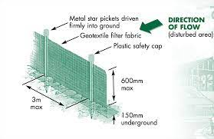

**Site map**

